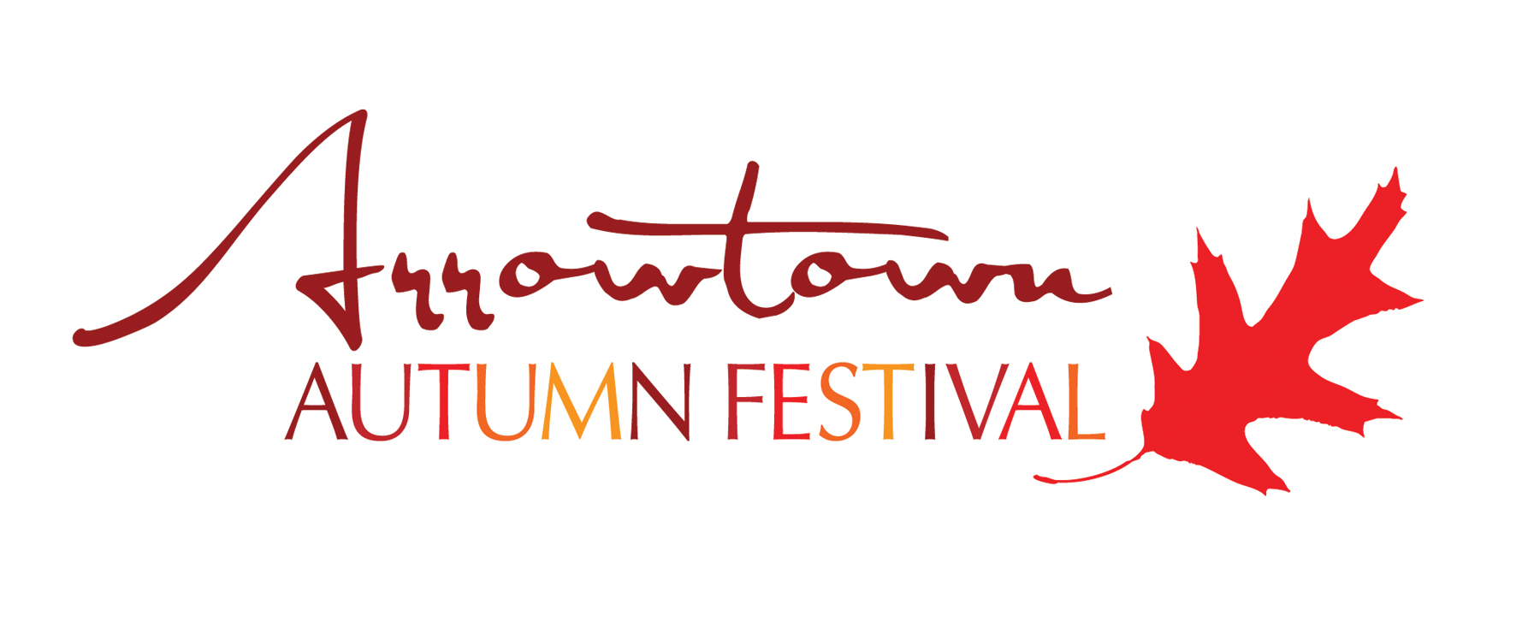
2016 Arrowtown Autumn Festival Parade
Saturday 23RD April

The parade is one of the Festival highlights and the committee would like to thank you for participating and making it a wonderful and colourful event.

THINGS YOU NEED TO KNOW:

The parade will start at 2pm - the idea is to keep a slow enough pace for the walkers but also keep it fast enough for the parade to flow nicely. It is important you don’t stop the parade to hand out goodies. Also please ensure all participants in your float are safe and secure.

All participants must assemble on Wilcox Green at 1.20pm at the latest – go to the marquee set up on the green where you will be given your number and place in the parade; please find where you should be in the line up and stay in that position throughout the parade.

Please do not throw lollies or handouts during the parade - this is purely for safety reasons as the numbers attending the parade each year has grown. We need to ensure everyone’s safety and we don’t want kids running on to the road, where there are moving vehicles, to pick up lollies. Please abide by this rule as it is there to protect everyone. We will have Parade Fairies that can hand out any goodies for you safely during the parade if you wish. You are also able to give handouts after the parade.

Float prizes – there will be two prizes up for grabs this year. Best Community Group Float and Best Business Float. The winner of the Best Business Float will receive a cash prize for which they can donate to a community group or charity of their choice.

Please complete the Booking Form attached and return to barrett.ne@gmail.com or post to PO Box 244 Arrowtown, 9351 by Friday 18th March.

Kind regards,

Ngaire, Carole and Stu

t: (03) 409 8688 e: barrett.ne@gmail.com
PARADE BOOKING FORM
Saturday 23rd April 2016

Description of Entry: _____________________________________________________________

Company/Organisation entering:___________________________________________________

Contact person: ________________________________________________________________

Contact phone: ______________________ Mobile: __________________________________

Contact email: _________________________________________________________________

We will be entering a float in the parade YES/NO
We will be walking in the parade YES /NO

Number of people participating in our entry ________

We will have animals participating in our entry YES/NO ___________________________

We will be providing music with our entry YES/NO

Please describe how your float will be towed _____________________________________

__________________________________________________________________________

Any other information you can provide regarding your entry:
__________________________________________________________________________

__________________________________________________________________________

__________________________________________________________________________

__________________________________________________________________________

__________________________________________________________________________

The above information will be used by the MC on the day to announce the entries as they pass by Buckingham Street.

t: (03) 409 8688 e: barrett.ne@gmail.com

